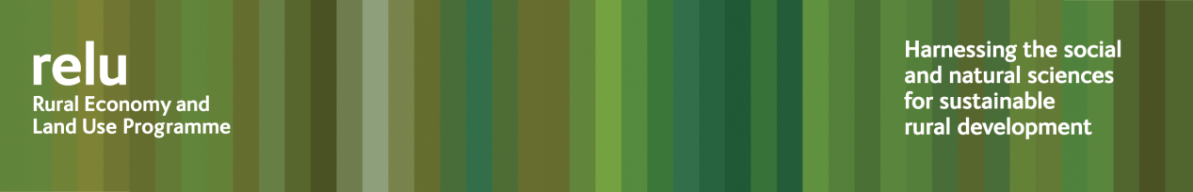
PRESS RELEASE

3 May 2011

Implementing the European Water Framework Directive could drive some farmers out of business

European legislation on improving water quality could have serious consequences for farmers and the sustainability of some rural communities, according to research carried out by the Rural Economy and Land Use Programme.

An interdisciplinary team, from the universities of East Anglia, Manchester, Cranfield and Aberystwyth, the Centre for Ecology & Hydrology and Askham Bryan College, has been investigating the implications of the European Water Framework Directive.

They say that policies designed to change agricultural land use – thereby reducing run-off of pollutants into water courses – could achieve significant improvements in water quality, but at the expense of farm incomes. This could have serious economic consequences for the countryside, while it would be the users of urban waterways for leisure who would benefit most.

At the same time, such policies could waste money, they say. Efficient use of resources is essential, but economic analyses of environmental benefits often fail to incorporate the natural variation that is characteristic of the real world. This means that they cannot recognise that spending in some areas is likely to be far more productive than in others. The researchers have developed sophisticated computer modelling techniques that enable policymakers to target funding by assessing, in money terms, the benefits created by improving rivers in each location. Not surprisingly, those benefits are much greater in highly populated areas.

This research makes it possible to link land use, farm incomes, water quality and recreation value, and highlight how each varies in different areas of the country. It provides a means of valuing the contribution the environment makes to human wellbeing. And it also helps to identify the real environmental priorities of individuals and communities. This enables decision-makers to target scarce resources to those areas which will respond most positively to additional spending.

Professor Ian Bateman from the Centre for Social and Economic Research on the Global Environment at the University of East Anglia, who led the research, said: “We have been able to conclude that the most efficient way of implementing the Water Framework Directive would be to target specific urban rivers that people actually use for leisure purposes, rather than trying to improve all rivers to pristine standard.

“It is also clear that in any given locality, once a certain level of improvement has been achieved, further measures make little difference to the environment or to the people who make use of it.

“We also have to recognise that those paying the costs of cleaning up rivers may not be the same people that enjoy the resulting benefits.

“These are important messages, particularly at a time of financial austerity and concerns over local communities. We argue that this approach should be applied routinely so as to help decision makers target environmental investments to provide the greatest gains to society.”

Notes for editors:
- The Rural Economy and Land Use Programme is an interdisciplinary collaboration between the Economic and Social Research Council (ESRC), the Biotechnology and Biological Sciences Research Council (BBSRC) and the Natural Environment Research Council (NERC), with additional funding provided by the Scottish Government and Defra. See www.relu.ac.uk for more information about the Relu programme.
- For more information about the research see Relu Policy and Practice Note No 28 and the project website.
- For any further information contact Science Communications Manager Anne Liddon, email anne.liddon@ncl.ac.uk , tel 0191 222 6903.

Ends

